ViM (Vehicle Interface Module) Setup
The ViM ( Vehicle Interface Module ) is a CANbus analog / digital input module designed to work with Aim products.
  - Import ViM CAN Protocol.

Open Race studio 3 and select CAN Protocols Fig 1.
The downloaded file ( AiM_TECH VIM ) can now be imported.

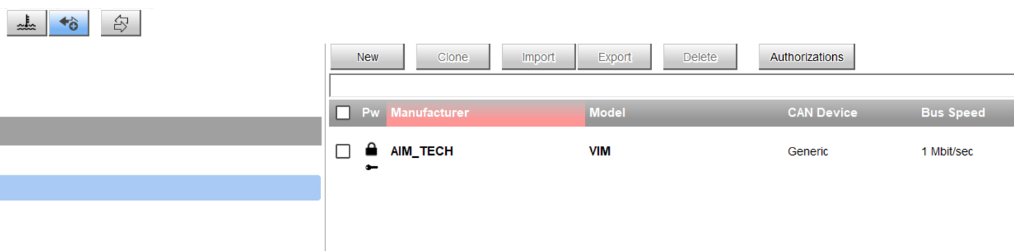
Fig 1

  - CAN2 Stream

In your configuration select (CAN2 Stream) Change Protocol, AIM TECH, VIM.

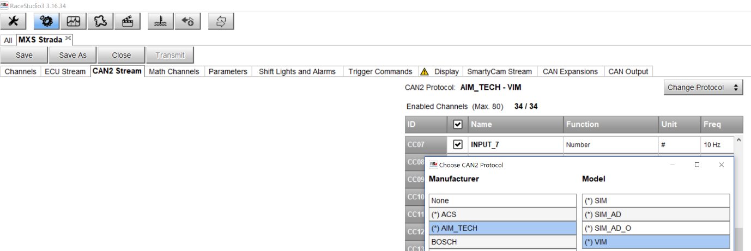
Fig 2

  - Input signals

Once the CAN protocol has been imported the ViM inputs can be renamed and scaled.
Scaling can be done in a RS3 ( Race Studio 3 ) Math Channel
Fig 3 shows the imported ViM_CAN protocol.
The 14 ViM inputs are universal inputs and listed below.
INPUT_1 to 4 : Ground Signal ( 2= Open 3= Closed to GND ) Note Only connect to GND ref circuits.
ANALOG_1 to 4 : Ground ref resistive Inputs ( Open or High resistance = 5000mV Grounded = 0mV millivolts) Note Only connect to GND ref circuits.
ANA_1_FILTER TO ANA_4_FILTER are the same as ANALOG_1 to 4 but filtered.
ANA_1_FIL_INV TO ANA_4_FIL_INV give a filtered and inverted signal compared to ANALOG_1 to 4,
This input option is used for fuel level sender units which read 0 Ω when the tank full.
ANALOG_5 to 13 are 0 to 11.4 Volt analog inputs, ANALOG_14 is a 0 to 33.6 Volt input.
INPUT_5 to 14: change from 0 to 1 at 4 Volts and are rated up to 33.6 Volts.
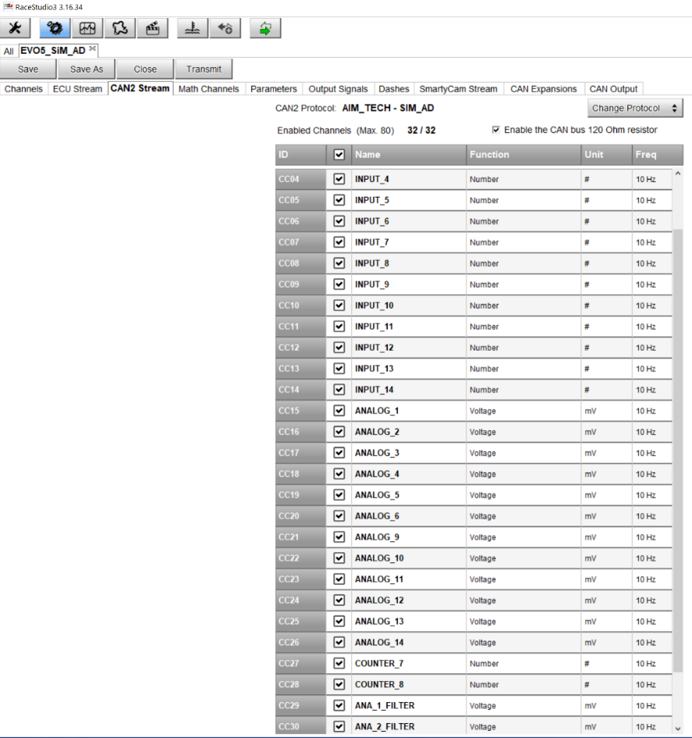
Fig 3

  - Fuel Level Setup

Connect the fuel level sender to the ViM ( Input 1 ) Channel.
If your fuel level sender decreases its resistance when full and increases when empty the ANA_1_FIL_INV value must be observed in RS3 Live Measures.
Fig 4 illustrates the tank full mV value of 5000 mV.
Fig 5 illustrates the tank empty value of 4391 mV.
Both your empty and full ANA_1_FIL_INV values can now be entered into the excel Multiplier /Offset Calculator.
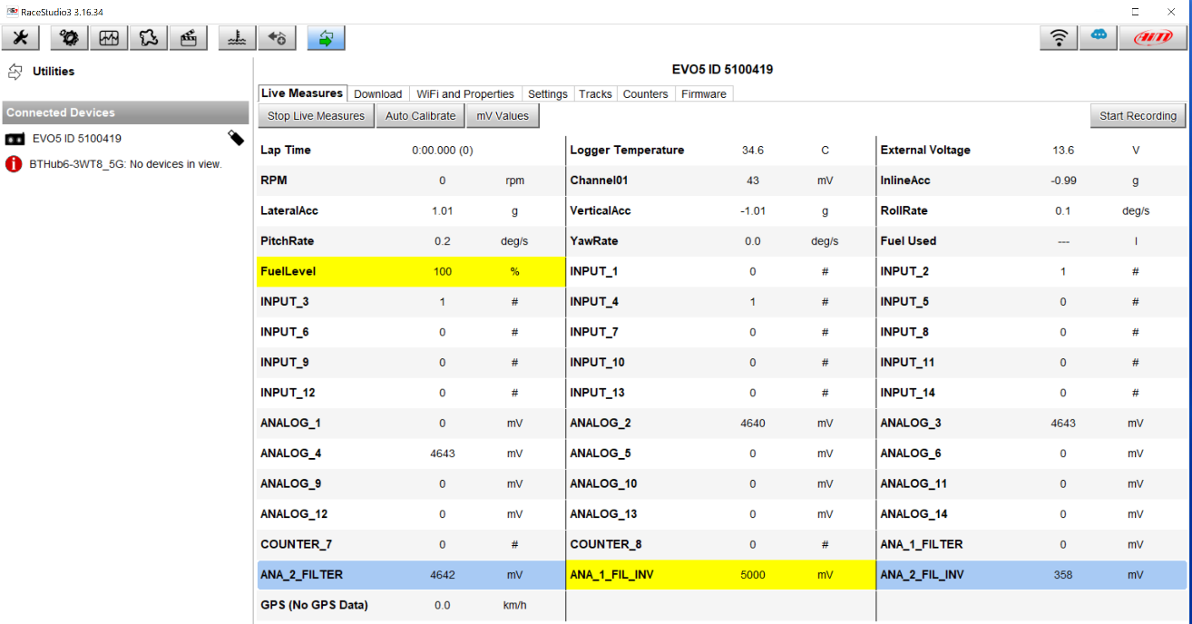
Fig 4
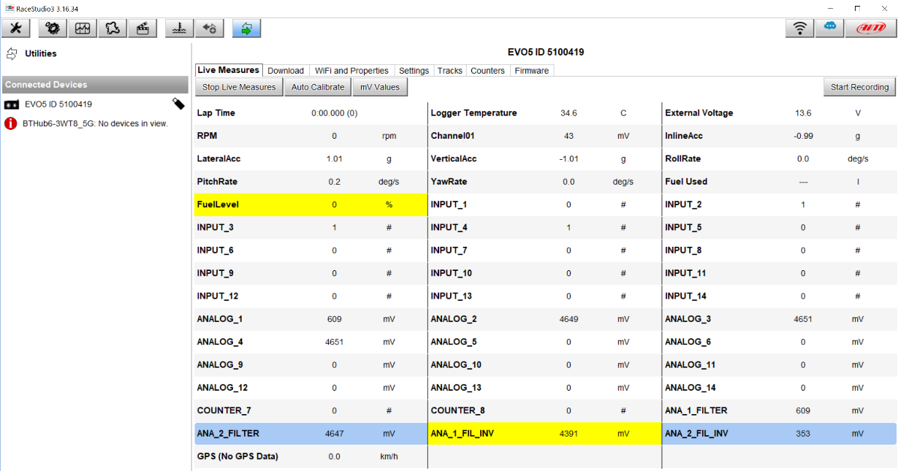
Fig 5

  - Math Channel Fuel Level Sender Cal

Fig 6 illustrates the Math setup procedure to create a new Fuel_Level channel reading 0% when empty and 100% when full.
Note: Only enter the above values into the yellow cells.
Create a new Math Channel called Fuel_Level.
Select ANA_1_FIL_INV for the ( Linear Correction Parameter )
The Multiplier and Offset values calculated in the spreadsheet can now be entered.
Note: The Offset value has been entered as a minus number ( -721 )

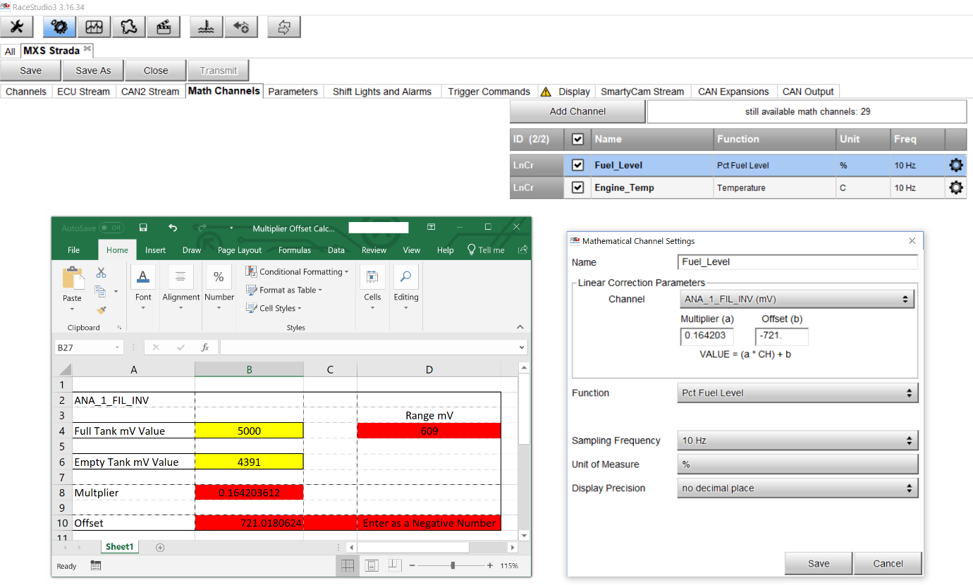
Fig 6

  - Math Channel Engine Temperature Sensor Cal

Fig 7 illustrates the Math setup procedure to create a new Engine Temperature sensor channel reading from0°C to 100°C
Note: Only enter the above values into the yellow cells.
Create a new Math Channel called Engine_Temp
Select ANA_2_FIL_INV for the ( Linear Correction Parameter )
The Multiplier and Offset values calculated in the spreadsheet can now be entered.
Note: The Offset value has been entered as a minus number ( -37.2 )

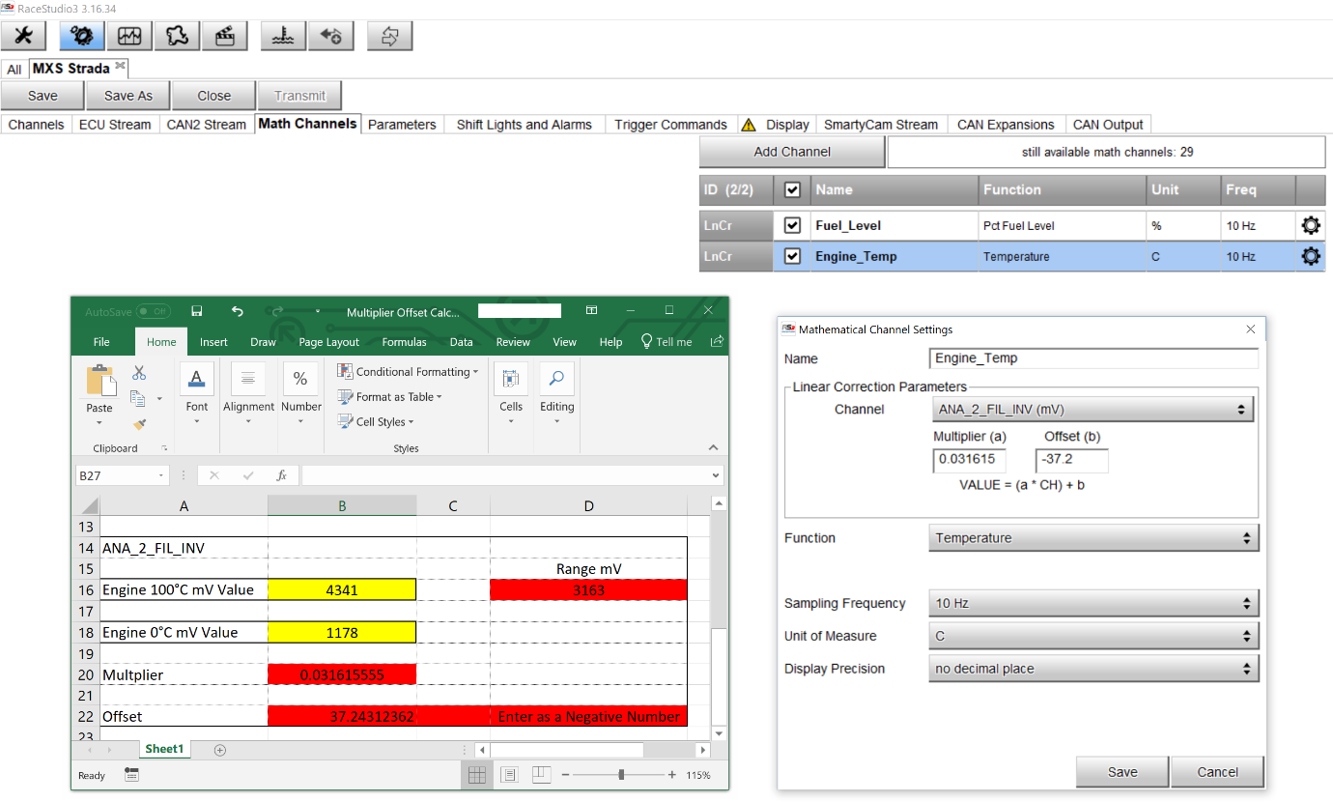
Fig 7

  - Shift Lights & Alarms

Fig 8 illustrates the procedure to assign a Low Fuel dash LED

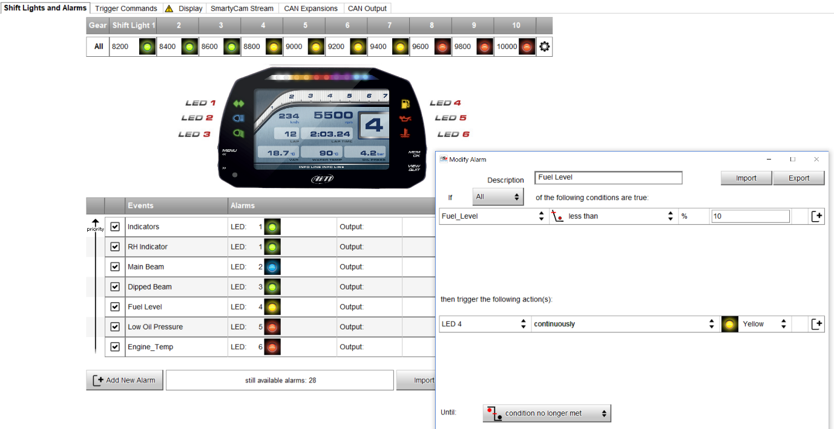
Fig 8

Fig 9 illustrates the procedure to assign a High Engine Temperature dash LED

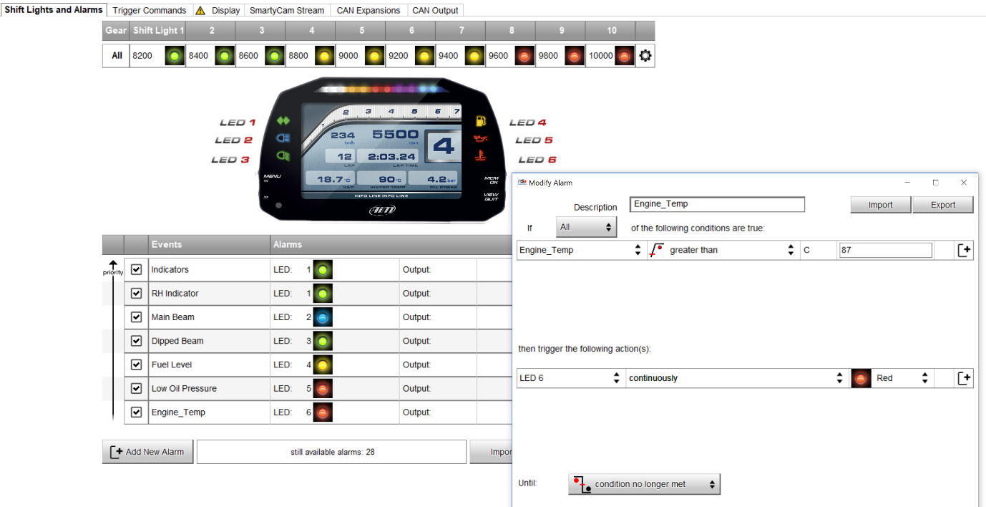
Fig 9

Fig 10 illustrates the procedure to assign a Indicator dash LED

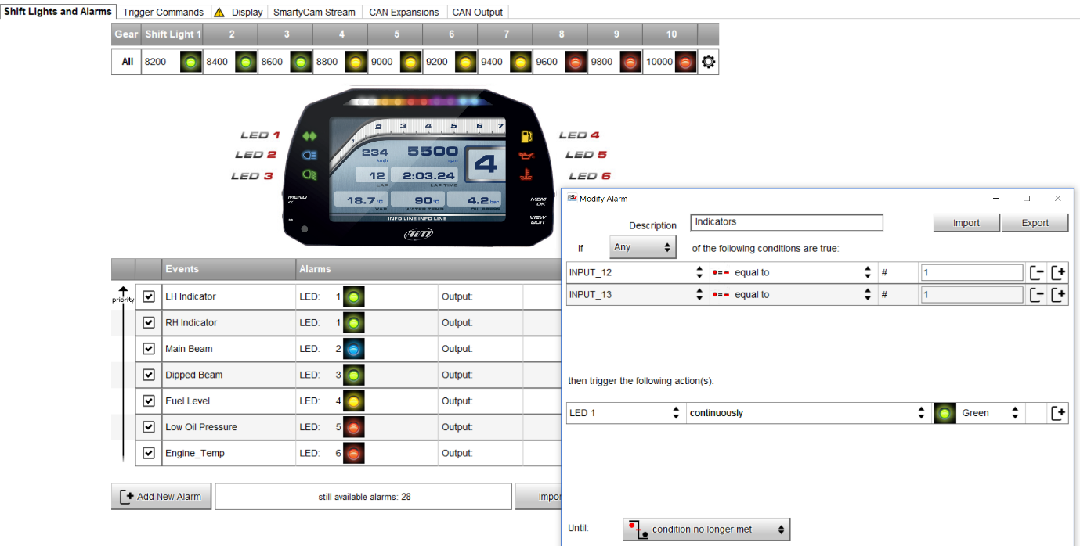
Fig 10

Fig 11 illustrates the procedure to assign a Main beam dash LED

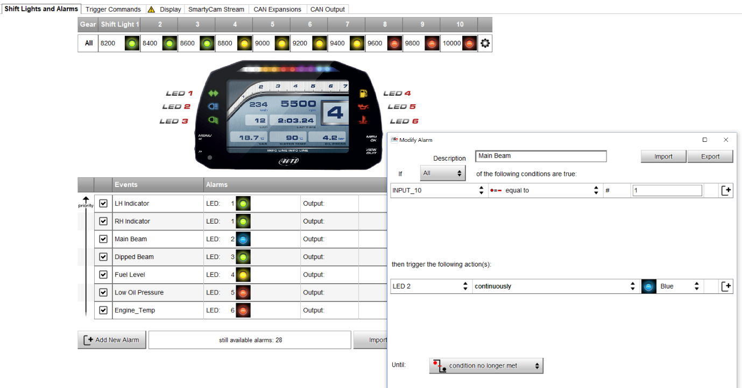
Fig 11

Fig 12 illustrates the procedure to assign a Low Oil Pressure dash LED
This input is connected to an oil pressure switch, When the engine is not running the circuit is to ground.
Note: When this input is grounded the input value = 3.
This can be seen below in Fig 12

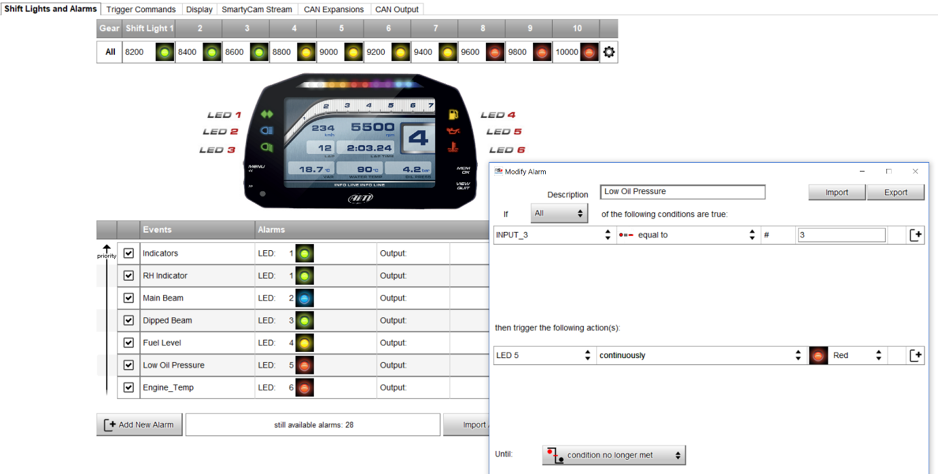
Fig 12

